

ORGANIZING DATA FOR ANALYTICS

FINAL PROJECT



Bala Durga Sridevi Kesavarapu

**Table of Contents**

**Executive Summary** 3

**Detail Project description**

Problem Statement 4

Identification of all entities, attributes, and relationships 4

Functional requirements 6

**Conceptual Database Design**

ER Diagram 7

Description of the entities, attributes, and relationships 8

Normalization 10

**Database Implementation**

Instance charts 11

Create Tables 14

Insert values 20

Script to delete Database 20

Queries 21

**Executive Summary**

The Supplemental Instruction Program (SIP) is a peer-led study group program for undergraduate students. SIP is an academic support program that utilizes collaborative learning strategies to assist students on the learning process. Historically speaking, the SIP is generally offered for the more advanced courses (i.e. higher difficulty). The program is staffed by one university employee, who is also the manager, Graduate Assistants who administer the program, and undergraduate student SIP Leaders. Each course may have more than one section and SIP offers distinct sessions for each section of the course. These sessions are led by SIP Leaders. These leaders are undergraduate students who have taken the course before and have been successful; earning a letter grade of B+ or higher. Leaders facilitate three review sessions each week, during which they incorporate learning strategies with instructional content specific to current coursework. Leaders communicate with the professor of the associated course to be aware of the current course material. Students are welcome to come and go at any point during the session. The sessions are open to any student enrolled in that particular course section. Students do not have to register for the SIP sessions in order to attend. Participants earn a reward if they attend 2 or more sessions, across courses, within a semester. Participants’ grades are recorded. Reports are generated for participants who attend a minimum of 3 sessions to display whether attendance results in a change in participants’ grades. The goal of SIP is:

* To demonstrate increased self-sufficiency, self-confidence and course knowledge compared to non-participants.
* To help participants earn higher test grades, course grades and persist more often than non-participants.
* To develop confidence in leaders as group facilitators as a result of SIP.

**Detail Project description**

* + **Problem statement**

Supplemental Instruction Program (SIP) needs an improved database to perform the following operations:

1. To document all individuals involved in the program
2. To track attendance every week.
3. To store the data specific to students, SIP leaders, classroom schedule.
4. To find students who attended 2 or more SIP sessions to compare their grades.
5. To find students who attended more than 2 SIP sessions to reward them.
6. Include location of sessions.
7. Create and deliver a streamlined database.
8. To provide meaningful information to determine the effectiveness of the SIP program.

**Identify all entities, attributes, and relationships that are commonly encountered with organization.**

|  |  |
| --- | --- |
| **Entity** | **Type** |
| Person |  |
| Department |  |
| Staff Member | Sub-type of Person |
| Administrator | Sub-type of Staff Member |
| Graduate Assistant | Sub-type of Staff Member |
| SIP Leader | Sub-type of Staff Member |
| Professor | Sub-type of Staff Member |
| Student | Sub-type of Person |
| Participant | Sub-type of Student |
| Student Athlete | Sub-type of Student |
| Course |  |
| Section |  |
| Session |  |
| Location |  |
| Attendance | Associative between Session and Participant |
| Reward |  |

|  |  |  |  |
| --- | --- | --- | --- |
| **Entity A** | **Relationship** | **Cardinality** | **Entity B** |
| SIP Leader | facilitates | 1:1 | section |
| Course offering | contains | 1:N | section |
| section | meets in | 1:1 | location |
| location | houses | 1:N | section |
| section | has | 1:N | session |
| participant | attends | 1:N | session |
| session | attended by | 1:N | participant |
| professor | associated with | 1:N | section |
| section | associated with | 1:1 | professor |
| SIP Leader | assigned to | 1:1 | professor |
| professor | assigned to | 1:N | SIP leader |
| participant | earns | 1:1 | reward |
| reward | earned by | 1:N | participant |
| staff member | may be a | complete disjoint | manager |
| staff member | may be a | complete disjoint | graduate assistant |
| staff member | may be a | complete disjoint | SIP leader |
| department | has | 1:1 | manager |
| manager | has | 1:N | graduate assistant |
| manager | has | 1:N | SIP leader |
| participant | may be a | incomplete overlapping | student athlete |
| student athlete | is a |  | participant |

**Collect and document the functional requirements: what is the database required to do?**

Typical functional requirements include:

1. The database stores all the Entities, Attributes and their Relationships constraints.
2. Querying the database and getting the required information is easy.
3. With increase in the size of data, the size of the database can be increased.
4. The data can be loaded easily from the flat files (.CSV, Excel) to the database.
5. Implementation of the Business rules based on the requirement is feasible.

**Conceptual Database Design**

* + **ER Diagram**
    - **Draw a complete entity relationship diagram that depicts your database. You can use any software to draw the ER diagram.**

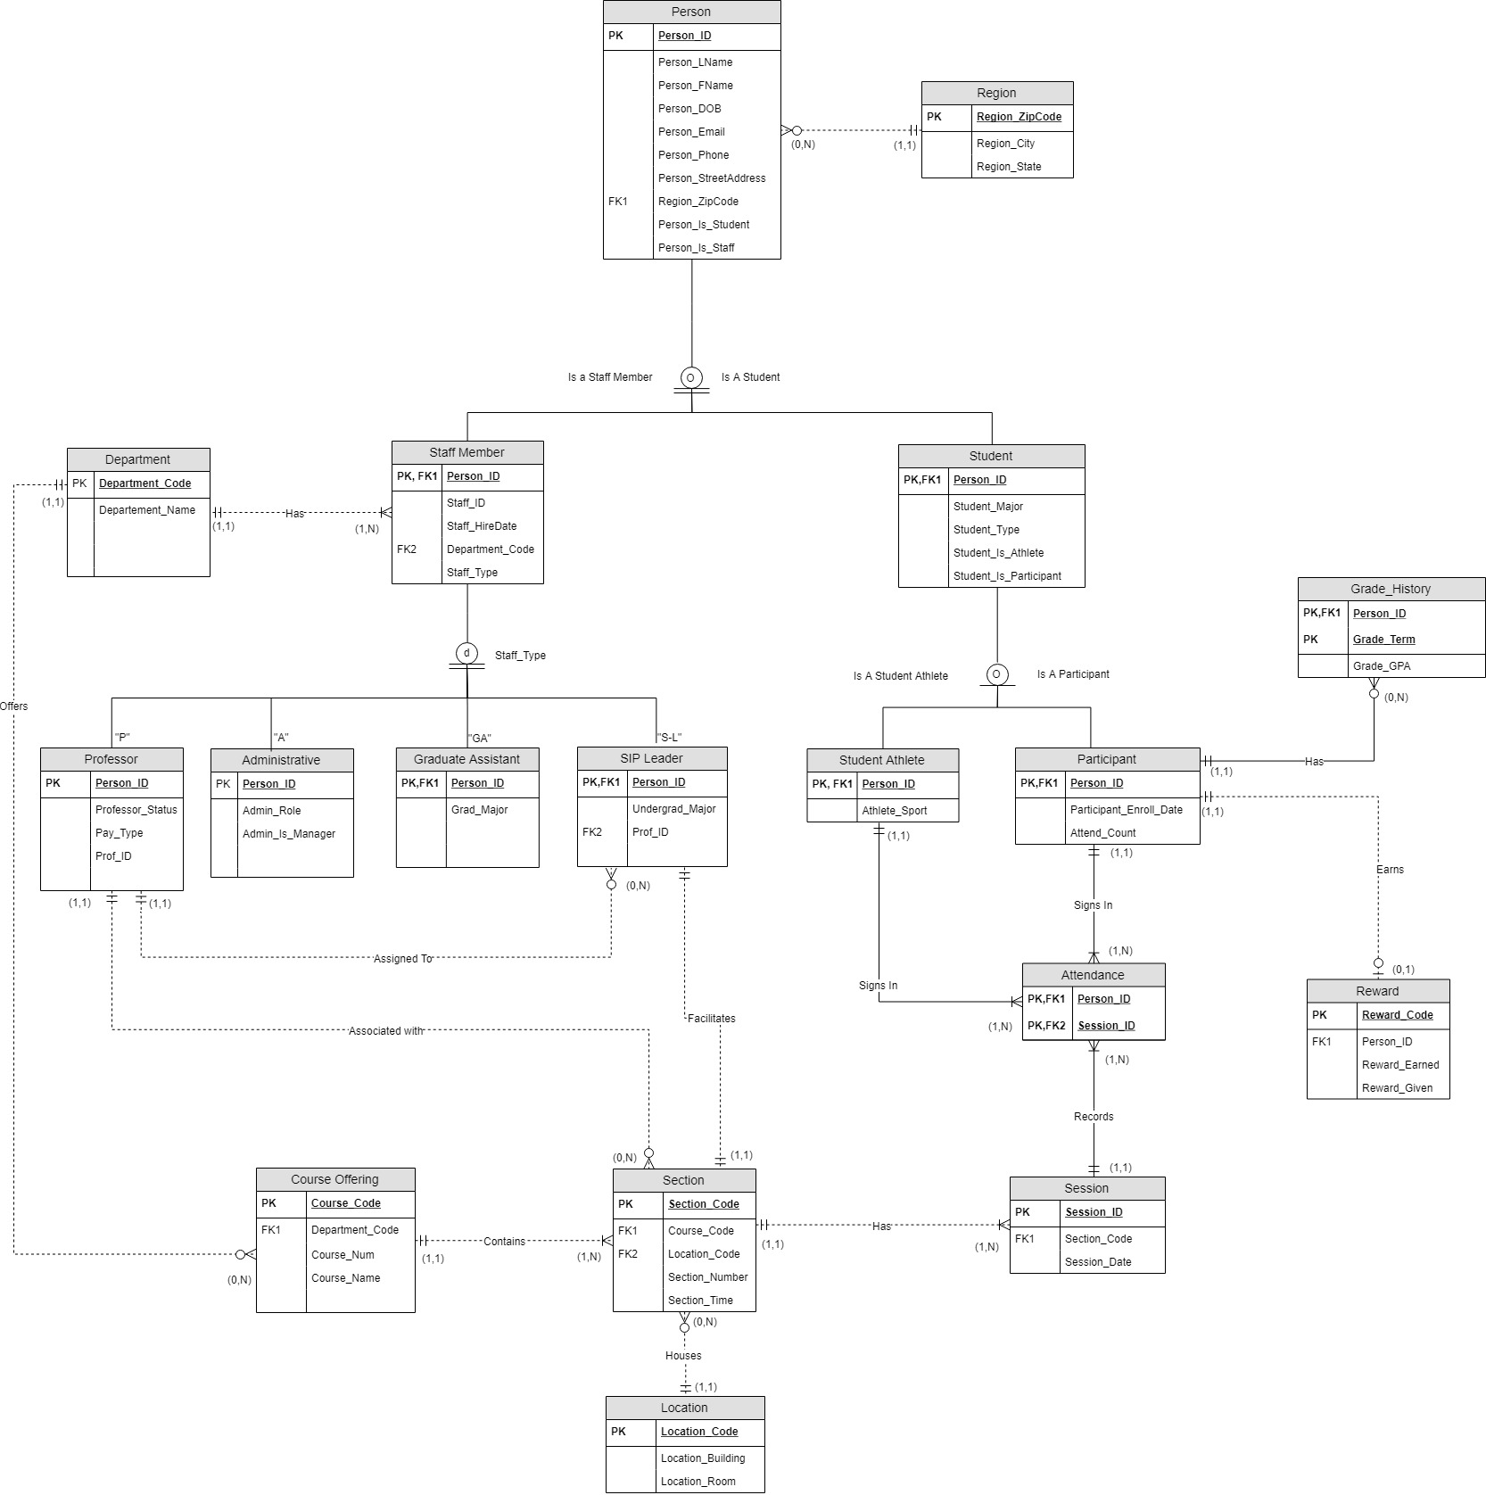

**Describe the entities, relationships, their respective attributes, the primary keys and constraints. State clearly any additional assumptions you have made.**

**Region:**

REGION has the REGION_ZIPCODE as the Primary Key and additional attributes REGION_CITY and REGION_STATE.

**Person:**

PERSON has the PERSON_ID as the Primary Key and has REGION_ZIPCODE as a Foreign Key. Additional attributes are PERSON_LNAME, PERSON_FNAME, PERSON_DOB, PERSON_EMAIL, PERSON_PHONE, PERSON_STREETADDRESS, PERSON_IS_STUDEN, PERSON_IS_STAFF, and PERSON_STATE. PERSON is a supertype in a specialization hierarchy representation, in a total overlapping relationship to STAFF_MEMBER and STUDENT.

**Staff Member:**

STAFF_MEMBER has the PERSON_ID as the Primary Key as well as a Foreign Key, and DEPARTMENT_CODE as a Foreign Key. Additional attributes are STAFF_ID, STAFF_HIREDATE, and STAFF_TYPE. STAFF_MEMBER is a subtype of PERSON, thus inheriting attributes of the PERSON table. STAFF_MEMBER also has a total disjoint relationship with subtypes PROFESSOR, ADMINISTRATIVE, GRADUATE_ASSISTANT, and SIP_LEADER.

**Department:**

DEPARTMENT has the DEPARTMENT_CODE as the Primary Key and additional attribute DEPARTMENT_NAME.

**Student:**

STUDENT has the PERSON_ID as a Primary Key as well as a Foreign Key, and it has inherited attributes from the PERSON table. Additional attributes are STUDENT_MAJOR, STUDENT_TYPE, STUDENT_IS_ATHLETE, and STUDENT_IS_PARTICIPANT)

**Professor:**

PROFESSOR has PERSON_ID as the Primary Key and has inherited attributes from the STAFF MEMBER table. Additional attributes are PERSON_ID, PROFESSOR_STATUS, PAY_TYPE, PROF_ID.

**Administrative:**

ADMINISTRATIVE has PERSON_ID as the Primary Key and has inherited attributes from the STAFF MEMBER table. Additional attributes are PERSON_ID, ADMIN_ROLE, and ADMIN_IS_MANAGER.

**Graduate Assistant:**

GRADUATE_ASSISTANT has PERSON_ID as the Primary Key and has inherited attributes from the STAFF MEMBER table. Additional attributes are PERSON_ID, and GRAD_MAJOR.

**SIP Leader:**

SIP_LEADER has PERSON_ID has both primary key as well as foreign key and PROF_ID as foreign key. It also has UNDERGRAD_MAJOR as an attribute which will have a list of undergrad majors of the students.

**Student Athlete:**

STUDENT_ATHLETE has PERSON_ID which is both Primary and foreign key of the table. It has ATHLETE_SPORT as an attribute which says weather a student is an athlete or not.

**Participant:**

PARTICIPANT has PERSON_ID which is both Primary and foreign key of the table. It has an attribute PARTICIPANT_ENROLL_DATE which has the dates of which the participants enrolled. It also has another attribute PARTICIPANT_ATTENDANCE_COUNT which has the number of sessions a participant attended.

**Attendance:**

ATTENDANCE has a composite key of PERSON_ID, SESSION_ID which are also foreign keys of the table.

**Grade History:**

GRADE_HISTORY has PERSON_ID attribute as both Primary Key and Foreign Key, thus making GRADE_HISTORY a weak entity. Other attributes are GRADE_TERM and GRADE_GPA.

**Reward:**

REWARD is a strong entity having REWARD_CODE as Primary Key and PERSON_ID as the Foreign Key. Additional attributes are PERSON_ID which is FK to Participant entity, REWARD_EARNED_DATE and REWARD_GIVEN_DATE.

**Course Offering:**

COURSE_OFFERING is a strong entity having COURSE_CODE as Primary Key and DEPARTMENT_CODE as the Foreign Key. Additional attributes are DEPARTMENT_CODE which is FK to Department entity, Course Num and COURSE_NAME.

**Section:**

SECTION is a strong entity having SECTION_CODE as the Primary Key, COURSE_CODE and LOCATION_CODE as Foreign Keys. SECTION participates in one-to-many relationship with SESSION. Other attributes are SECTION_NUMBER and SECTION_TIME.

**Session:**

SESSION has SESSION_ID as Primary Key and SECTION_CODE as Foreign Key and SESSION_DATE.

**Location:**

LOCATION is a clustered entity which groups Room and Buildings and relationships. LOCATION has LOCATION_CODE as Primary Key and is a strong entity. Other attributes are LOCATION_BUILDING and LOCATION_ROOM.

**Normalization - Decompose the relations into 3NF.**

All the tables are in 3NF. The normalized tables are described in the instance charts below.

**Database Implementation**

**Develop instance charts for all tables in your database.**

1. REGION (REGION_ZIPCODE, REGION_CITY, REGION_STATE)

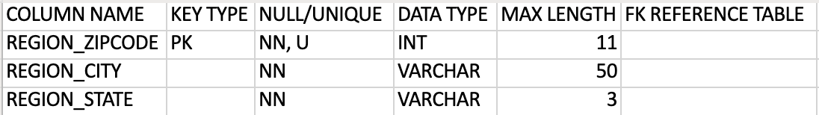

2. PERSON (PERSON_ID, PERSON_LNAME, PERSON_FNAME, PERSON_DOB, PERSON_EMAIL, PERSON_PHONE, PERSON_STREETADDR, REGION_ZIPCODE, PERSON_IS_STUDENT, PERSON_IS_STAFF)

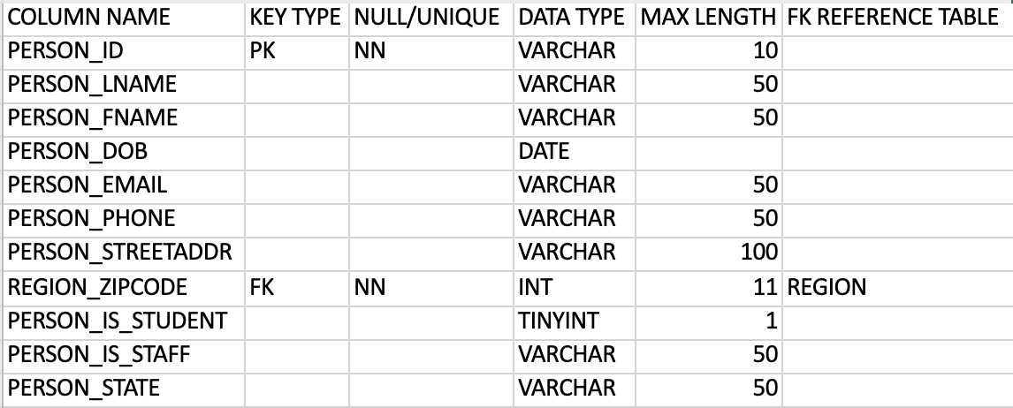

3. STAFF_MEMBER (PERSON_ID, STAFF_ID, STAFF_HIREDATE, DEPARTMENT_CODE, STAFF_TYPE)

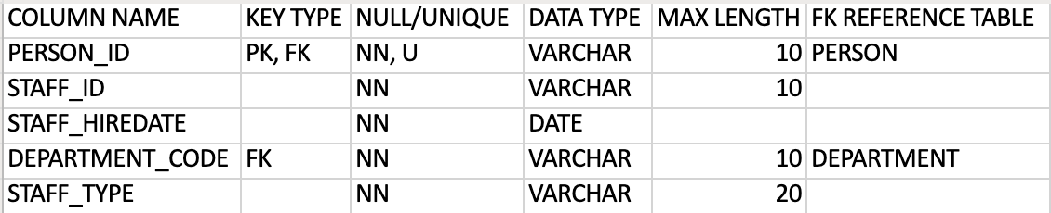

4. DEPARTMENT (DEPARTMENT_CODE, DEPARTMENT_NAME)

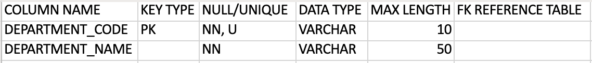

5. STUDENT (PERSON_ID, STUDENT_MAJOR, STUDENT_TYPE, STUDENT_IS_ATHLETE, STUDENT_IS_PARTICIPANT)

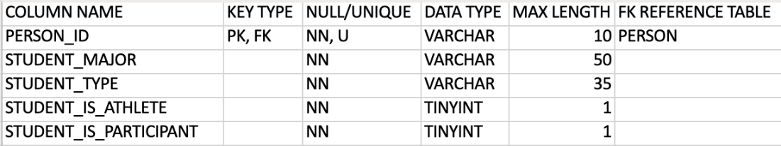

6. PROFESSOR (PERSON_ID, PROF_ID, PROFESSOR_STATUS, PAY_TYPE)

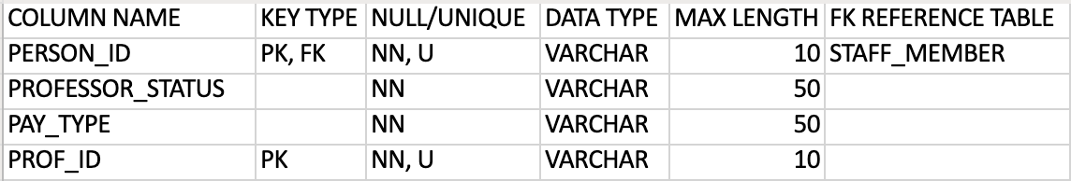

7. ADMINISTRATIVE (PERSON_ID, ADMIN_ROLE, ADMIN_IS_MANAGER)

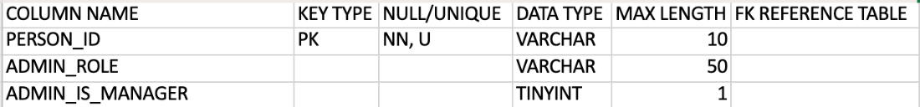

8. GRADUATE_ASSISTANT (PERSON_ID, GRAD_MAJOR)

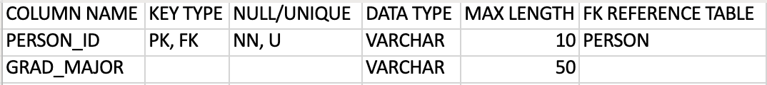

9. SIP_LEADER (PERSON_ID, UNDERGRAD_MAJOR, PROF_ID)

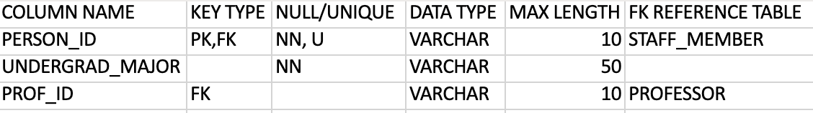

10. STUDENT_ATHLETE (PERSON_ID, ATHLETE_SPORT)

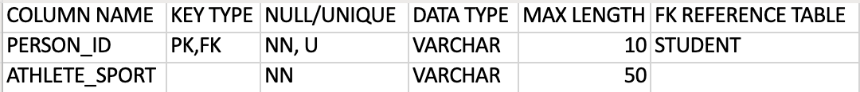

11. PARTICIPANT (PERSON_ID, PARTICIPANT_ENROLL_DATE, PARTICIPANT_ATTENDANCE_COUNT)

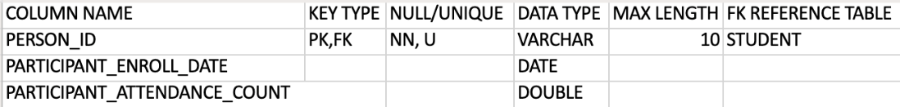

12. ATTENDANCE (PERSON_ID, SESSION_ID)

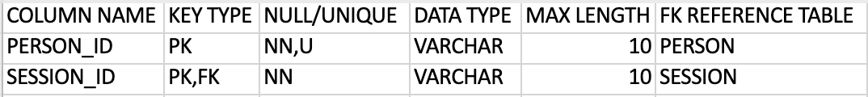

13. REWARD (REWARD_CODE, PERSON_ID, REWARD_EARNED_DATE, REWARD_GIVEN_DATE, REWARD_TYPE)

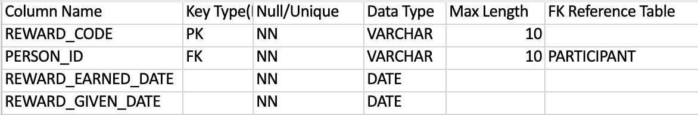

14. SESSION (SESSION_ID, SECTION_CODE, SESSION_DATE)

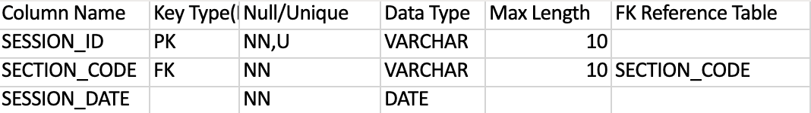

15. SECTION (SECTION_CODE, COURSE_CODE, LOCATION_CODE, SECTION_NUMBER, SECTION_TIME)

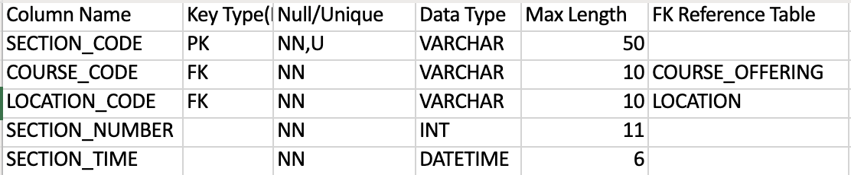

16. COURSE_OFFERING (COURSE_CODE, DEPARTMENT_CODE, COURSE_NAME, COURSE_NUM)

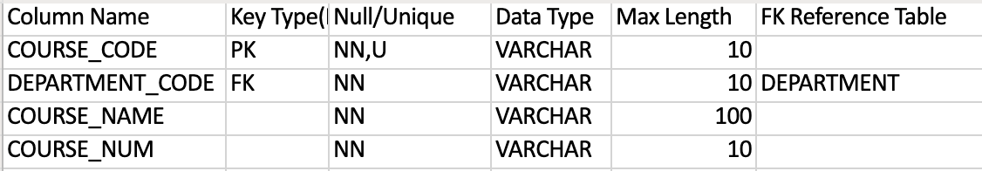

17. GRADE_HISTORY (PERSON_ID, GRADE_TERM, GRADE_GPA, GRADE_GPA_CHANGE)

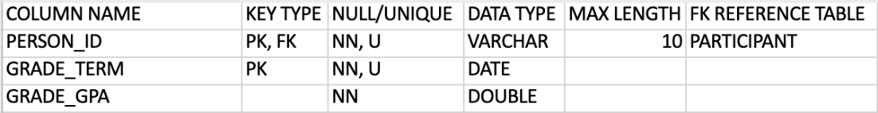

18. LOCATION (LOCATION_CODE, LOCATION_BUILDING, LOCATION_ROOM)

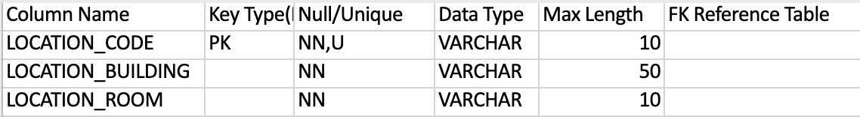

**Implement the database on a MySQL server. Specifically, write a SQL script to do the following:**

1. **Create the Tables. Each Table must have a Primary Key constraint, Foreign Key constraints where applicable, and other constraints as necessary.**

/* ISM-671 Spring2019

Group Project

Group 1 */

/* Create Statements */

/* Region; Jeremiah: */

CREATE TABLE REGION (

REGION_ZIPCODE VARCHAR (11) NOT NULL UNIQUE,

REGION_CITY VARCHAR (50),

REGION_STATE CHAR (3),

PRIMARY KEY(REGION_ZIPCODE)

);

/* Person; Jeremiah: */

CREATE TABLE PERSON (

PERSON_ID VARCHAR (10) NOT NULL UNIQUE,

PERSON_LNAME VARCHAR (50) NOT NULL,

PERSON_FNAME VARCHAR (50) NOT NULL,

PERSON_DOB DATE NOT NULL,

PERSON_EMAIL VARCHAR (50) NOT NULL,

PERSON_PHONE VARCHAR (50) NOT NULL,

PERSON_STREETADDR VARCHAR (100)

REGION_ZIPCODE INT (11) NOT NULL,

PERSON_IS_STUDENT TINYINT (1) NOT NULL,

PERSON_IS_STAFF VARCHAR (50) NOT NULL,

PERSON_STATE VARCHAR (50)

PRIMARY KEY(PERSON_ID),

FOREIGN KEY(REGION_ZIPCODE) REFERENCES REGION(REGION_ZIPCODE) ON UPDATE CASCADE

);

/* Department; Jeremiah: */

CREATE TABLE DEPARTMENT (

DEPARTMENT_CODE VARCHAR (10) NOT NULL UNIQUE,

DEPARTMENT_NAME VARCHAR (50) NOT NULL,

PRIMARY KEY(DEPARTMENT_CODE)

);

/* Staff Member; Jeremiah: */

CREATE TABLE STAFF_MEMBER (

PERSON_ID VARCHAR (10) NOT NULL UNIQUE,

STAFF_ID VARCHAR (10) NOT NULL UNIQUE,

STAFF_HIREDATE DATE NOT NULL,

DEPARTMENT_CODE VARCHAR (10) NOT NULL,

STAFF_TYPE VARCHAR (20) NOT NULL,

PRIMARY KEY(PERSON_ID),

FOREIGN KEY(PERSON_ID) REFERENCES PERSON(PERSON_ID) ON UPDATE CASCADE ON DELETE RESTRICT,

FOREIGN KEY(DEPARTMENT_CODE) REFERENCES DEPARTMENT(DEPARTMENT_CODE) ON UPDATE CASCADE ON DELETE RESTRICT

);

/* Student; Prithvi: */

CREATE TABLE STUDENT (

PERSON_ID VARCHAR (10) NOT NULL UNIQUE,

STUDENT_ID VARCHAR (10) NOT NULL UNIQUE,

STUDENT_MAJOR VARCHAR (35),

STUDENT_TYPE CHAR (10),

STUDENT_IS_ATHLETE TINYINT (1),

STUDENT_IS_PARTICIPANT TINYINT (1),

PRIMARY KEY (PERSON_ID),

FOREIGN KEY (PERSON_ID) REFERENCES PERSON (PERSON_ID) ON UPDATE CASCADE

);

/* Professor; Prithvi: */

CREATE TABLE PROFESSOR (

PERSON_ID VARCHAR (10) NOT NULL UNIQUE,

PROFESSOR_STATUS VARCHAR (10),

PAY_TYPE VARCHAR (50),

PROF_ID VARCHAR (10) NOT NULL

PRIMARY KEY (PERSON_ID)

);

/* Administrative; Prithvi: */

CREATE TABLE ADMINISTRATIVE (

PERSON_ID VARCHAR (10) NOT NULL UNIQUE,

ADMIN_ROLE VARCHAR (10),

ADMIN_IS_MANAGER TINYINT (1),

PRIMARY KEY (PERSON_ID)

);

/* Graduate Assistant; Prithvi: */

CREATE TABLE GRADUATE_ASSISTANT (

PERSON_ID VARCHAR (10) NOT NULL UNIQUE,

GRAD_MAJOR VARCHAR (50),

PRIMARY KEY (PERSON_ID),

FOREIGN KEY (PERSON_ID) REFERENCES PERSON (PERSON_ID) ON UPDATE CASCADE,

FOREIGN KEY (STUDENT_ID) REFERENCES STUDENT (STUDENT_ID) ON UPDATE CASCADE

);

/* SIP Leader; Sridevi: */

CREATE TABLE SIP_LEADER (

PERSON_ID VARCHAR (10) NOT NULL UNIQUE,

UNDERGRAD_MAJOR VARCHAR (50),

PROF_ID VARCHAR (10)

PRIMARY KEY (PERSON_ID),

FOREIGN KEY (PERSON_ID) REFERENCES PERSON (PERSON_ID) ON UPDATE CASCADE,

FOREIGN KEY (STUDENT_ID) REFERENCES STUDENT (STUDENT_ID) ON UPDATE CASCADE

);

/* Student Athlete; Sridevi: */

CREATE TABLE STUDENT_ATHLETE (

PERSON_ID CHAR (11) NOT NULL UNIQUE,

ATHLETE_SPORT CHAR (10),

PRIMARY KEY (PERSON_ID),

FOREIGN KEY (PERSON_ID) REFERENCES PERSON (PERSON_ID) ON UPDATE CASCADE

);

/* Participant; Sridevi: */

CREATE TABLE PARTICIPANT (

PERSON_ID VARCHAR (10) NOT NULL UNIQUE,

PARTICIPANT_ENROLL_DATE DATE,

PARTICIPANT_ATTENDANCE_COUNT DOUBLE,

PRIMARY KEY (PERSON_ID),

FOREIGN KEY (PERSON_ID) REFERENCES PERSON (PERSON_ID) ON UPDATE CASCADE

);

/* Attendance; Sridevi: */

CREATE TABLE ATTENDANCE (

PERSON_ID VARCHAR (10) NOT NULL UNIQUE,

SESSION_ID VARCHAR (10) NOT NULL UNIQUE,

PRIMARY KEY (PERSON_ID, SESSION_ID),

FOREIGN KEY(PERSON_ID) REFERENCES PERSON,

FOREIGN KEY(SESSION_ID) REFERENCES SESSION ON UPDATE CASCADE

);

/* Reward; Anita: */

CREATE TABLE REWARD (

REWARD_CODE VARCHAR (10) NOT NULL UNIQUE,

PERSON_ID VARCHAR (10) NOT NULL UNIQUE,

REWARD_EARNED_DATE DATE,

REWARD_GIVEN_DATE DATE,

PRIMARY KEY (REWARD_CODE),

FOREIGN KEY (PERSON_ID) REFERENCES PARTICIPANT (PERSON_ID) ON UPDATE CASCADE ON DELETE RESTRICT);

/* Session; Anita: */

CREATE TABLE SESSION (

SESSION_ID VARCHAR (50) NOT NULL UNIQUE,

SECTION_CODE VARCHAR (10) NOT NULL UNIQUE,

COURSE_CODE VARCHAR (10) NOT NULL,

LOCATION_CODE VARCHAR (10) NOT NULL,

SECTION_NUMBER INT (11) NOT NULL,

SECTION_TIME DATETIME (6) NOT NULL,

PRIMARY KEY (SESSION_ID),

FOREIGN KEY (SECTION_CODE) REFERENCES SECTION (SECTION_CODE) ON UPDATE CASCADE ON DELETE RESTRICT);

/* Section; Anita: */

CREATE TABLE SECTION (

SECTION_CODE CHAR (10) NOT NULL UNIQUE,

COURSE_CODE CHAR (10) NOT NULL UNIQUE,

LOCATION_CODE CHAR (10) NOT NULL UNIQUE,

SECTION_NUMBER VARCHAR (10) NOT NULL,

SECTION_TIME VARCHAR (10) NOT NULL,

PRIMARY KEY (SECTION_CODE),

FOREIGN KEY (COURSE_CODE) REFERENCES COURSE_OFFERING (COURSE_CODE) ON UPDATE CASCADE ON DELETE RESTRICT,

FOREIGN KEY (LOCATION_CODE) REFERENCES LOCATION (LOCATION_CODE) ON UPDATE CASCADE ON DELETE RESTRICT);

/* Course Offering; Anita: */

CREATE TABLE COURSE_OFFERING (

COURSE_CODE VARCHAR (10) NOT NULL UNIQUE,

DEPARTMENT_CODE VARCHAR (10) NOT NULL UNIQUE,

COURSE_NAME VARCHAR (100) NOT NULL,

COURSE_NUM VARCHAR (10) NOT NULL,

PRIMARY KEY (COURSE_CODE),

FOREIGN KEY (DEPARTMENT_CODE) REFERENCES DEPARTMENT (DEPARTMENT_CODE) ON UPDATE CASCADE ON DELETE RESTRICT);

/* Location; Anita: */

CREATE TABLE LOCATION (

LOCATION_CODE VARCHAR (10) NOT NULL UNIQUE,

LOCATION_BUILDING VARCHAR (50) NOT NULL,

LOCATION_ROOM VARCHAR (10) NOT NULL,

PRIMARY KEY (LOCATION_CODE));

/* Grade_History; Anita: */

CREATE TABLE GRADE_HISTORY (

PERSON_ID VARCHAR (10) NOT NULL UNIQUE,

GRADE_TERM DATE NOT NULL,

GRADE_GPA DOUBLE NOT NULL,

PRIMARY KEY(PERSON_ID),

FOREIGN KEY (PERSON_ID) REFERENCES PARTICIPANT (PERSON_ID) ON UPDATE CASCADE ON DELETE RESTRICT);

1. **Insert rows into each Table. Make up your own data. Make sure that each table has between 2 and 10 rows.**

We have inserted at least two rows for all the tables using realistic fictional values**.**

1. **Write a SQL script to delete the entire database, i.e., drop all Tables.**

DROP DATABSE GROUP_PROJECT;

**(OR)**

DROP TABLE PERSON

DROP TABLE REGION

DROP TABLE DEPARTMENT

DROP TABLE STAFF_MEMBER

DROP TABLE STUDENT

DROP TABLE PROFESSOR

DROP TABLE ADMINISTRATIVE

DROP TABLE GRADUATE_ASSISTANT

DROP TABLE SIP_LEADER

DROP TABLE STUDENT_ATHLETE

DROP TABLE PARTICIPANT

DROP TABLE REWARD

DROP TABLE SESSION

DROP TABLE SECTION

DROP TABLE COURSE_OFFERING

DROP TABLE LOCATION

DROP TABLE ATTENDANCE

DROP TABLE GRADE_HISTORY

1. **Develop five queries to retrieve some meaningful data from the database.**
2. Provide a list of Professors who are assigned to the SIP Leaders.

**QUERY:**

SELECT T1. PERSON_LNAME AS PROF_FNAME,

T1. PERSON_FNAME AS PROF_LNAME,

T2. PERSON_LNAME AS SIPLEADER_LNAME,

T2. PERSON_FNAME AS SIPLEADER_FNAME

FROM

(SELECT P. [PERSON_ID], [PERSON_LNAME],[PERSON_FNAME], PROF_ID

FROM [DBO]. [PERSON] P JOIN [DBO]. [PROFESSOR] PR

ON P. PERSON_ID = PR. PERSON_ID) T1

LEFT JOIN

(SELECT P. [PERSON_ID],[PERSON_LNAME],[PERSON_FNAME] , PROF_ID

FROM [DBO].[PERSON] P JOIN [DBO].[SIP_LEADER] S

ON P. PERSON_ID = S. PERSON_ID) T2

ON T1. PROF_ID = T2. PROF_ID

**OUTPUT:**

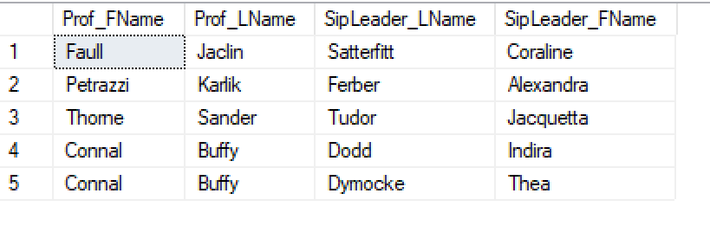

1. Provide a list of Students who received rewards.

**QUERY:**

SELECT P.PERSON_FNAME,

P.PERSON_LNAME,

[REWARD_EARNED_DATE],

[REWARD_GIVEN_DATE]

FROM [dbo].[REWARD] R

JOIN [dbo].[PERSON] P ON R.PERSON_ID = P.PERSON_ID

**OUTPUT:**

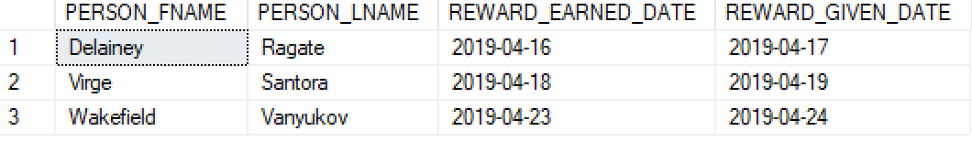

1. Provide a report of Students who got an increase in the GPA by attending the program.

**QUERY:**

SELECT P.PERSON_FNAME AS 'STUDENT FIRST NAME',P.PERSON_LNAME AS 'STUDENT LAST NAME'

FROM PERSON P JOIN STUDENT S ON P.PERSON_ID = S.PERSON_ID

JOIN PARTICIPANT PA ON S.PERSON_ID = PA.PERSON_ID

JOIN GRADE_HISTORY G ON PA.PERSON_ID = G.PERSON_ID

JOIN (

SELECT ST.PERSON_ID, ST.GRADE_GPA AS 'START GPA', FN.GRADE_GPA AS 'END GPA'

FROM (SELECT PERSON_ID, GRADE_GPA FROM GRADE_HISTORY WHERE (PERSON_ID, GRADE_TERM) IN

(SELECT PERSON_ID, MIN(GRADE_TERM) FROM GRADE_HISTORY GROUP BY PERSON_ID))ST

JOIN

(SELECT PERSON_ID, GRADE_GPA FROM GRADE_HISTORY WHERE (PERSON_ID, GRADE_TERM) IN

(SELECT PERSON_ID, MAX(GRADE_TERM) FROM GRADE_HISTORY GROUP BY PERSON_ID))FN

ON ST.PERSON_ID = FN.PERSON_ID

WHERE FN.GRADE_GPA > ST.GRADE_GPA)CH ON G.PERSON_ID = CH.PERSON_ID

GROUP BY P.PERSON_ID;

**OUTPUT:**

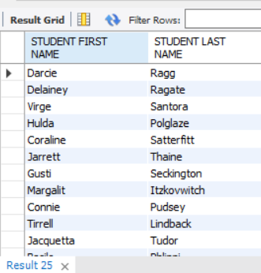

1. Provide listing of Staff Members who are from NC and sort the list by Last Name.

**QUERY:**

SELECT PERSON_FNAME AS 'STAFF FIRST NAME', PERSON_LNAME AS 'STAFF LAST NAME', PERSON_EMAIL AS EMAIL, DEPARTMENT_NAME AS DEPARTMENT

FROM REGION R JOIN PERSON P ON R.REGION_ZIPCODE = P.REGION_ZIPCODE

JOIN STAFF_MEMBER ST ON P.PERSON_ID = ST.PERSON_ID

JOIN DEPARTMENT D ON ST.DEPARTMENT_CODE = D.DEPARTMENT_CODE

ORDER BY PERSON_LNAME;

**OUTPUT:**

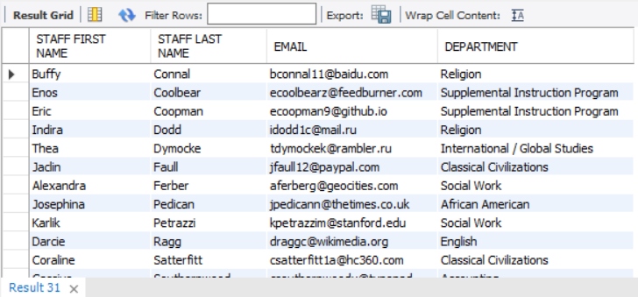

1. Provide a list of Students who are doing Graduate Assistantship.

**QUERY:**

SELECT P.PERSON_ID, P.PERSON_FNAME, P.PERSON_LNAME, G.GRAD_MAJOR

FROM PERSON P, GRADUATE_ASSISTANT G

WHERE P.PERSON_ID = G.PERSON_ID

ORDER BY P.PERSON_FNAME

**OUTPUT:**

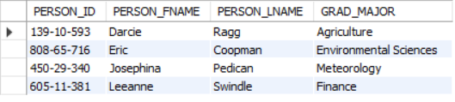

1. Provide a list of Professors who have more than one SIP Leader.

**QUERY:**

SELECT P.PERSON_LNAME, P.PERSON_FNAME, S.PROF_ID

FROM PROFESSOR PR

JOIN PERSON P ON P.PERSON_ID= PR.PERSON_ID

JOIN SIP_LEADER S ON

S.PROF_ID= PR.PROF_ID

GROUP BY P.PERSON_ID

HAVING COUNT(S.PROF_ID) > 1

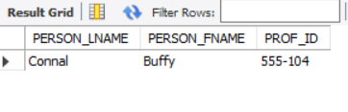

1. Provide a list of Students who participated in 2 or more SIP sessions.

**QUERY:**

SELECT STUDENT.PERSON_ID, PERSON.PERSON_FNAME, PERSON.PERSON_LNAME

FROM STUDENT, PERSON, PARTICIPANT

WHERE STUDENT.PERSON_ID = PERSON.PERSON_ID AND PERSON.PERSON_ID = PARTICIPANT.PERSON_ID

GROUP BY PERSON.PERSON_ID, PARTICIPANT.PARTICIPANT_ATTENDANCE_COUNT, STUDENT.PERSON_ID, PERSON.PERSON_FNAME, PERSON.PERSON_LNAME

HAVING PARTICIPANT_ATTENDANCE_COUNT >=2;

**OUTPUT:**

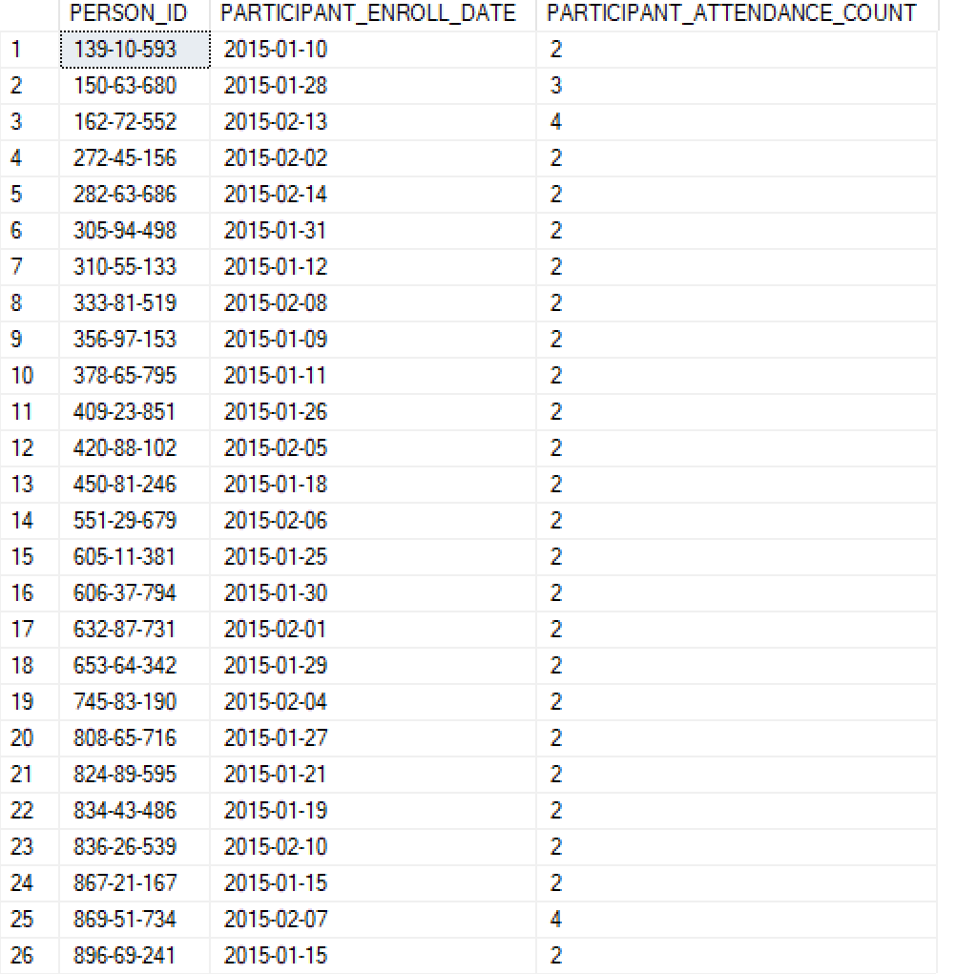

1. Provide a list of Students who are undergrads.

SELECT STUDENT.PERSON_ID, PERSON.PERSON_FNAME, PERSON.PERSON_LNAME

FROM PERSON, STUDENT

WHERE STUDENT.PERSON_ID = PERSON.PERSON_ID AND PERSON.PERSON_IS_STUDENT = 1 AND STUDENT.STUDENT_TYPE = 'Undergrad'

GROUP BY PERSON.PERSON_ID, STUDENT.PERSON_ID, PERSON.PERSON_FNAME, PERSON.PERSON_LNAME

ORDER BY PERSON.PERSON_FNAME, PERSON.PERSON_LNAME;

**OUTPUT:**

